FUNCTION MACHINES
Pearson Edexcel - Tuesday 19 May 2020 - Paper 1 (Non-Calculator) Foundation Tier

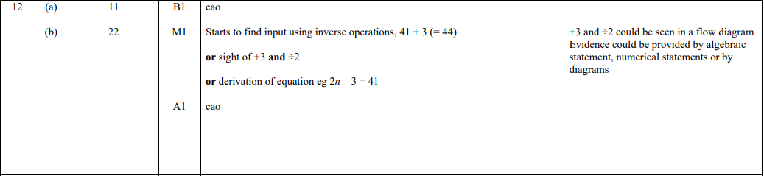

Pearson Edexcel - Thursday 8 November 2018 - Paper 2 (Calculator) Foundation Tier

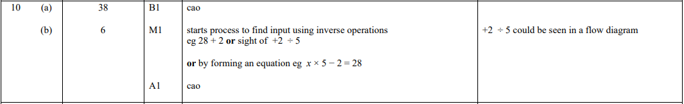

OCR Thursday 6 June 2019 – Morning (Non-Calculator) Foundation Tier
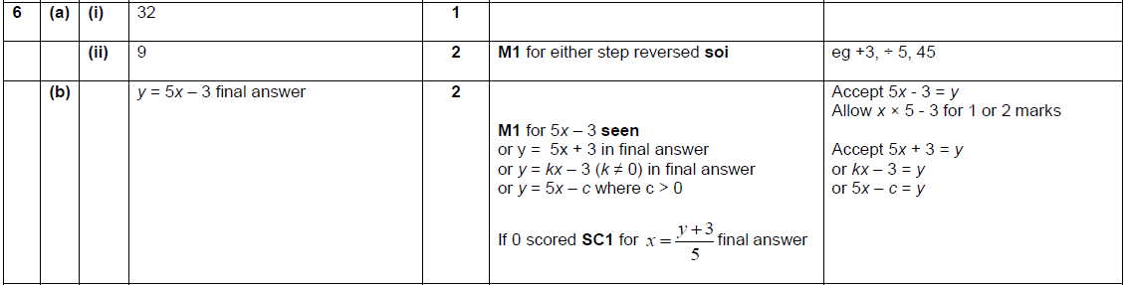

OCR Tuesday 6 November 2018 – Morning (Calculator) Foundation Tier

OCR Monday 6 November 2017– Morning (Calculator) Foundation Tier
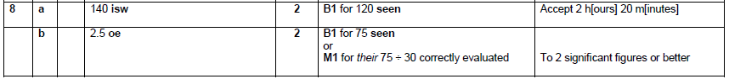

Pearson Edexcel – Sample Papers - Paper 3 (Calculator) Foundation Tier

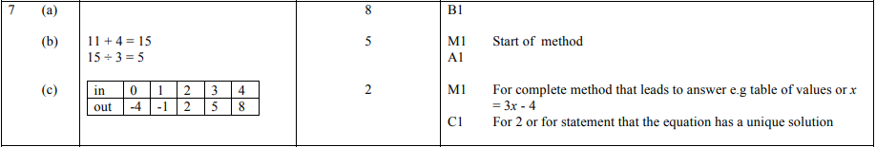
AQA Thursday 4 June 2020 – Morning (Calculator) Foundation Tier

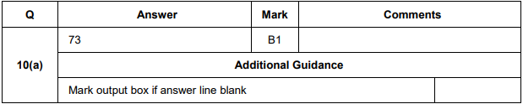
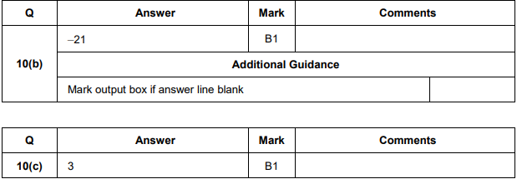

AQA Thursday 11 June 2019 – Morning (Calculator) Foundation Tier

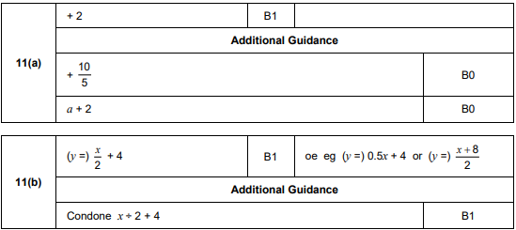
AQA Wednesday 8 November 2017 – Morning (Calculator) Foundation Tier

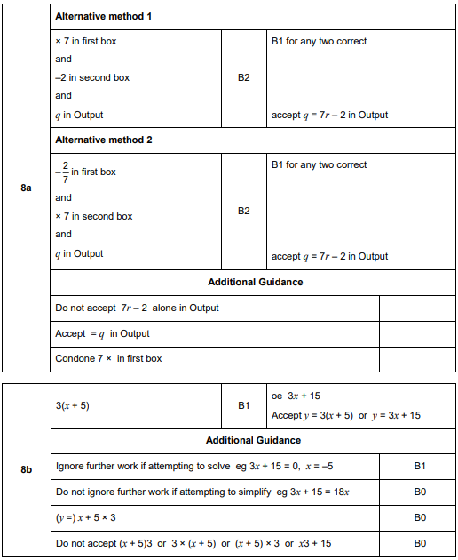

AQA Tuesday 13 June 2017 Morning– Morning (Calculator) Foundation Tier

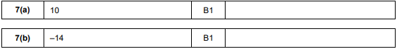
AQA Sample Paper 2– Morning (Calculator) Foundation Tier

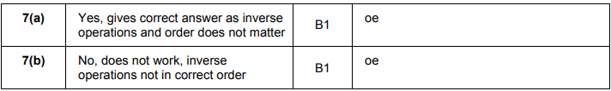
AQA Sample Paper 2– Morning (Calculator) Foundation Tier

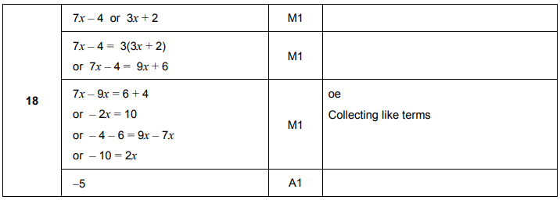
AQA Sample Paper 3– Morning (Calculator) Foundation Tier

